**SUBNETTING**

STEP 1 : **SUBNET MASK**

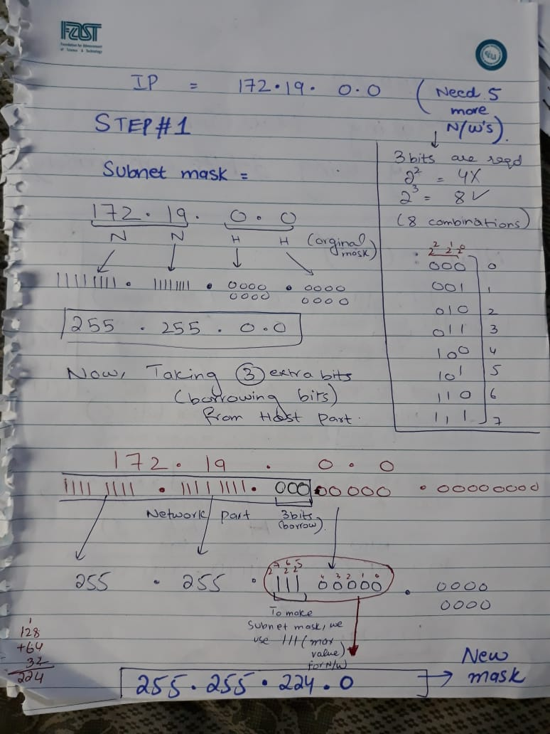

STEP 2 : **MORE NETWORKS**

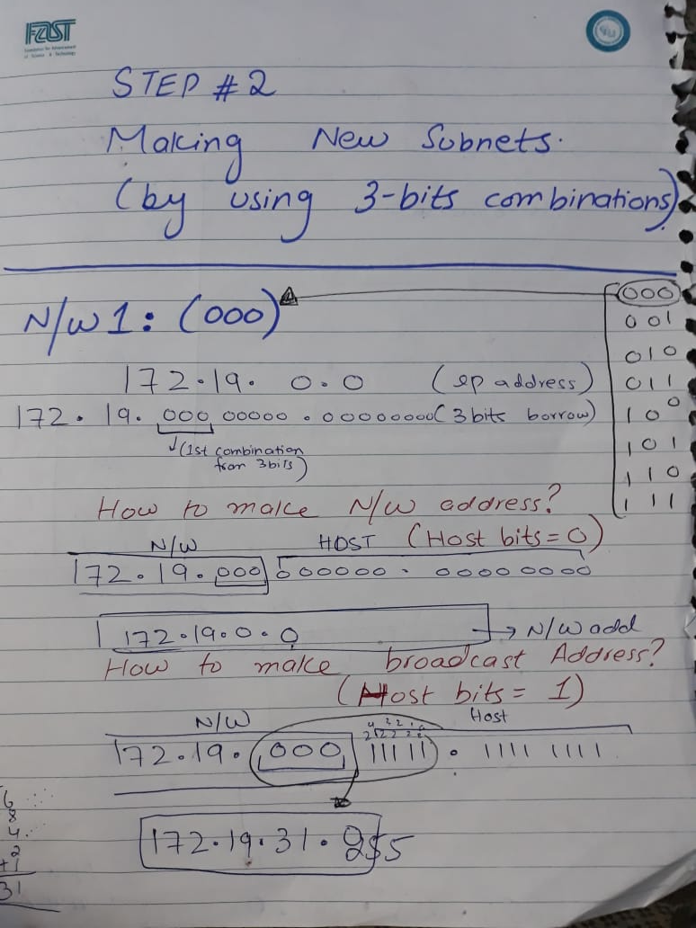

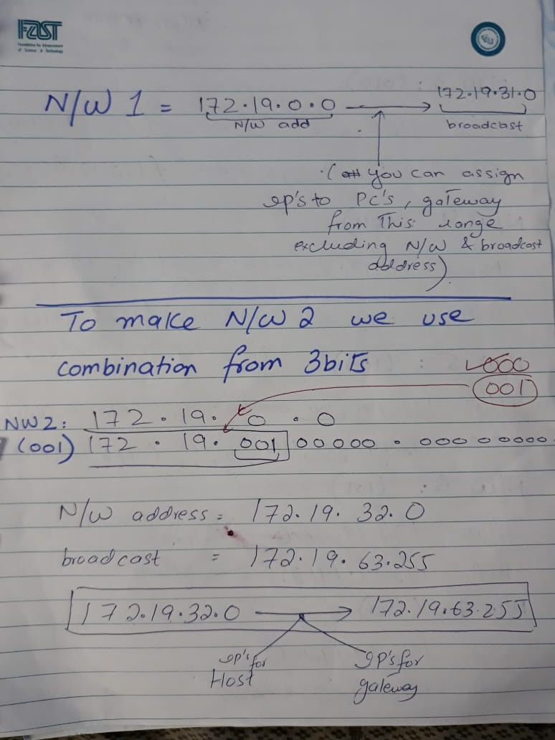

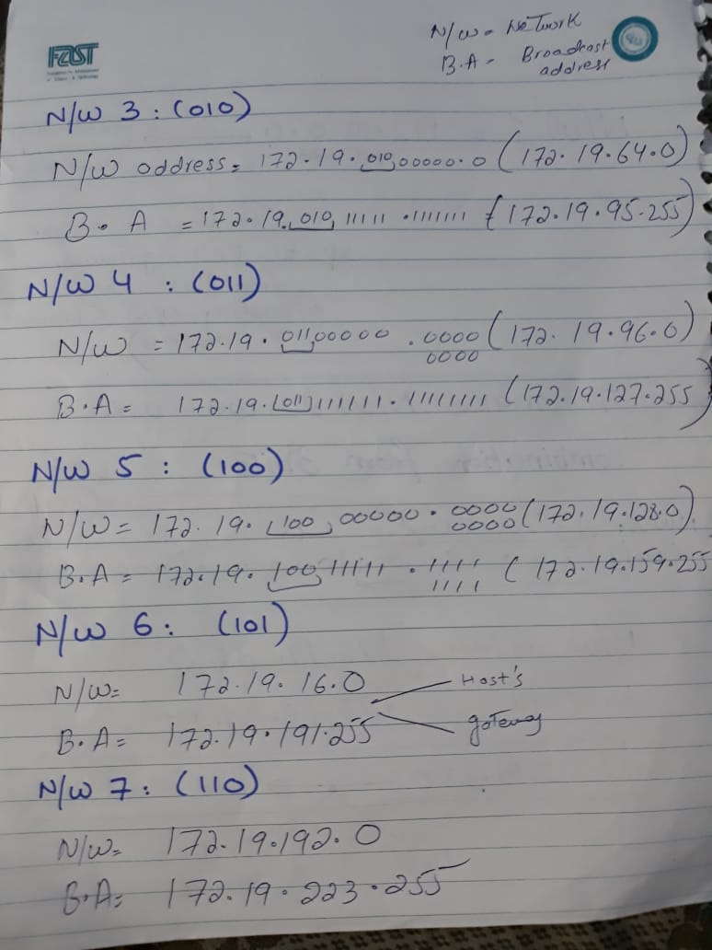

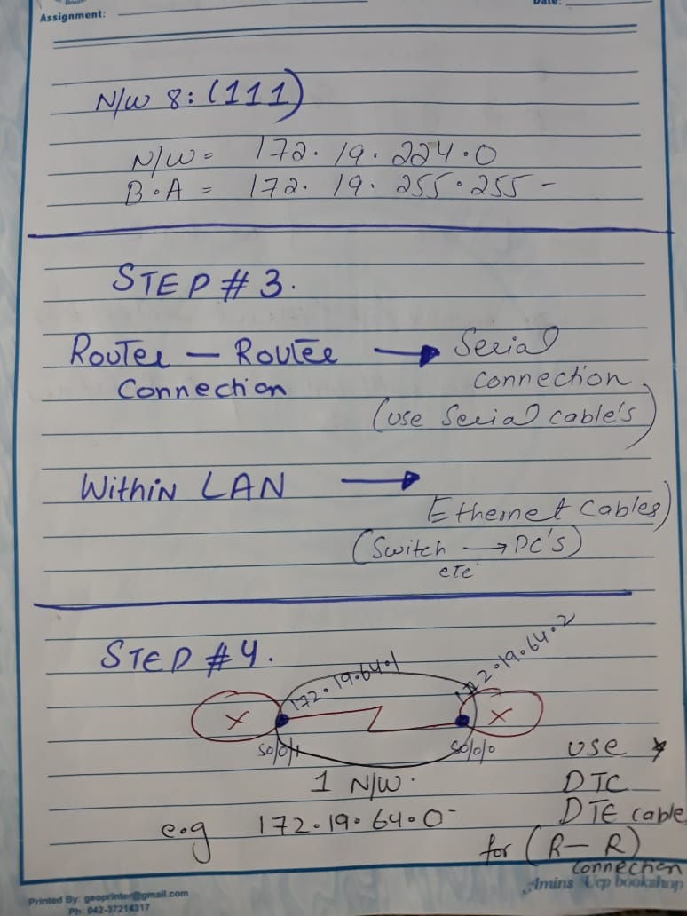

**FOR YOUR INFORMATION**

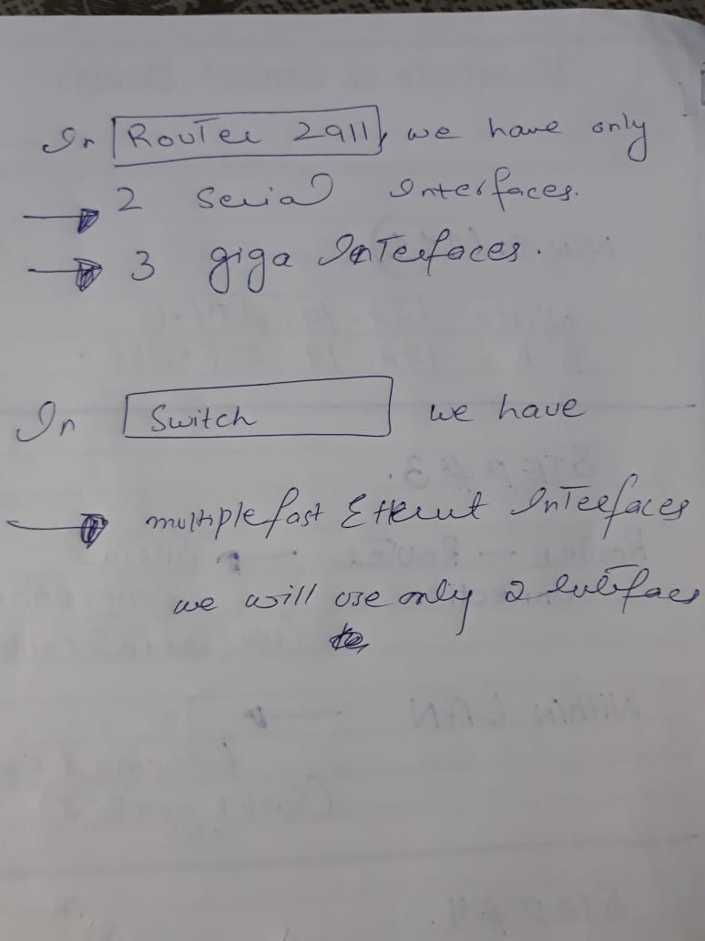

PACKET TRACER

STEP 1 : **MAKING NETWORK**

**We need 7 different networks**

**5 network ( lab 1, lab2 , lab 3 , Faculty and Staff)**

**2 more networks for (R1 - R2) & (R2 – R3)**

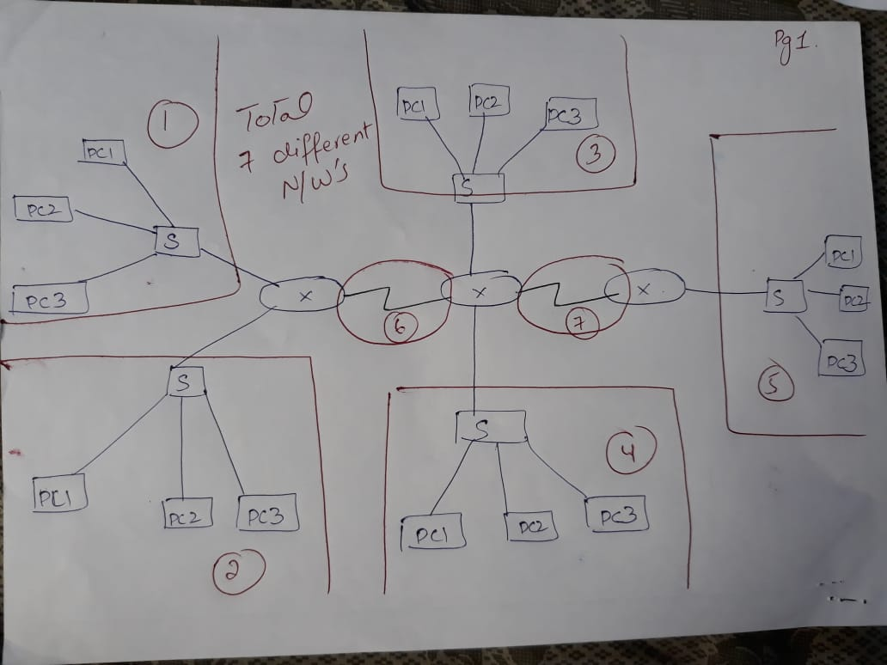

STEP 2 : **ASSIGNING IP ADDRESS TO EACH NETWORK**

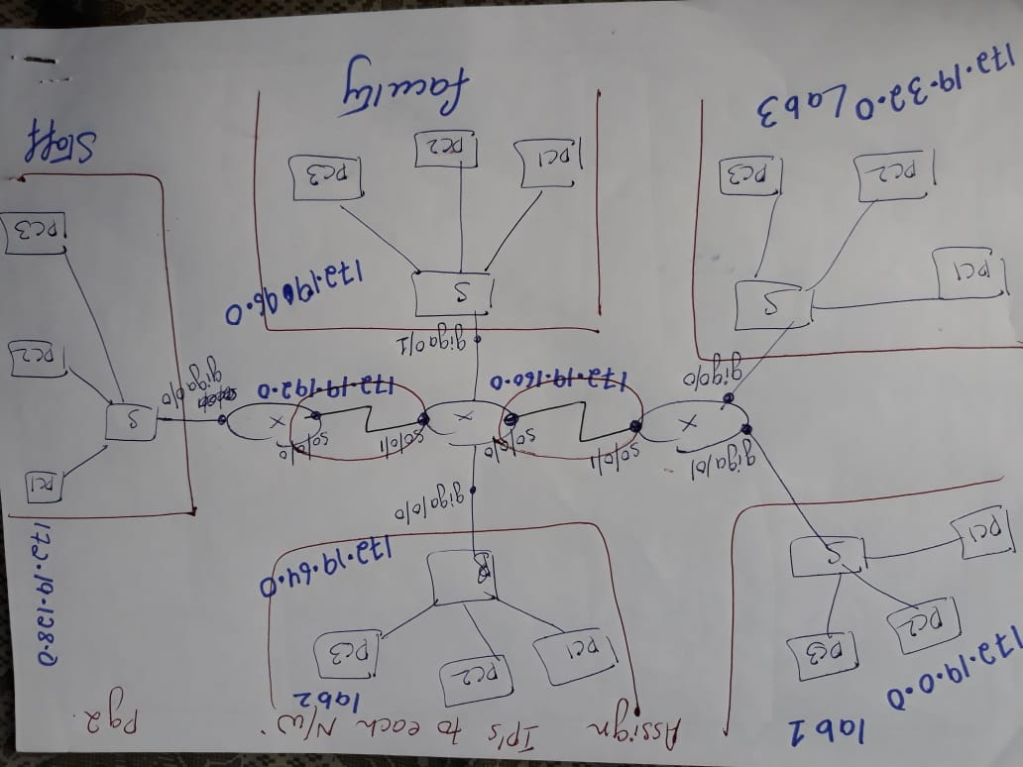

STEP 3 : **ASSIGNING IP ADDRESS TO HOSTS IN EACH NETWORK**

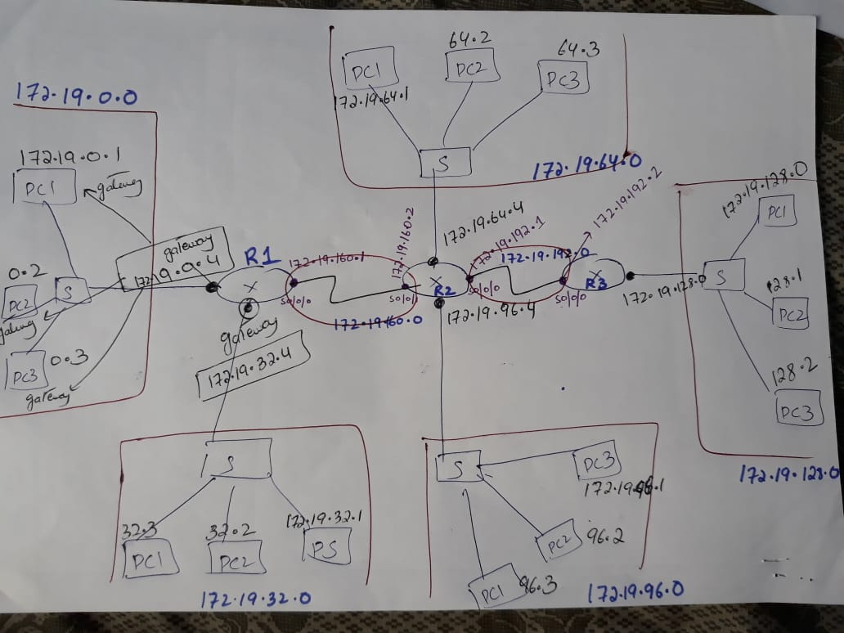

STEP 4 : **ASSIGNING GATEWAY ADDRESS IN ROUTERS**

**(Taking Router 2 – Having 4 Interfaces**

**2 – Giga Interface (LAN Interface)**

**2 – Serial Interface (WAN Interface)**

